 |  | Case Study | April 2023  Issue 1
 |  | SSE Bordon
Client  SSE  Location  Bordon, Hampshire  Contract value  £5.0m  Services  Principle Contractor Civils & cable install Backfill & reinstatement 33kV cable install Fiber Optics Install Workforce Management Site Supervision |  | 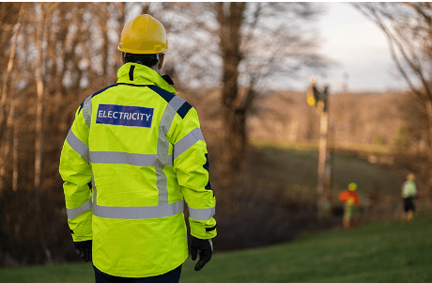

Project Summary
The SSE Bordon project is a two-year delivery programme valued at approximately £2.5 million per year, commencing in April 2023. For this project, the Employer (SSEN) acted as both principle contractor and principle designer, Durkin and Sons provided the operational resource to undertake the feasibility work, civil and overall project oversight, executing the full installation of the 33kV cable system and associated civil works.
The scope included excavation, duct installation, cable installation and associated permanent reinstatement activities. The scope included fibre optic cabling across the defined cable routes. Durkin and Sons supplied and managed all labour, plant, tools, PPE, transport, project staffing, and welfare, ensuring that SSEN policies and safety procedures were fully observed. Day-to-day site management—including supervision, team administration, programme adherence, and performance was also provided by Durkin and Sons.
This project supported SSEN’s ongoing network reinforcement and reliability enhancement programme, enabling safe, timely, and flexible mobilisation of specialist cable installation teams was provided by Durkin and Sons.

Project Overview
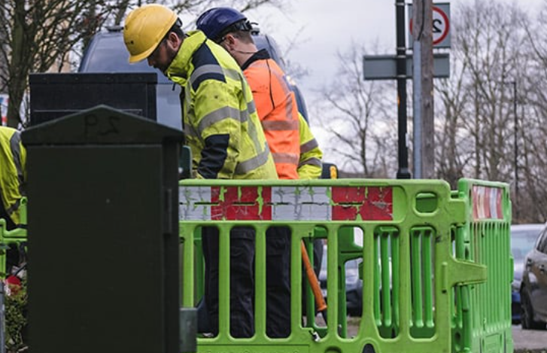  Engineering Challenges & Solutions  The SSE Bordon project faced a range of engineering challenges, including congested utility corridors, variable ground conditions, and the need to maintain safe traffic and public interfaces while delivering extensive excavation, duct installation, and 33kV cable works. Buildability issues and field variations required close coordination with SSEN’s design and delivery teams, while strict safety, human factors and PPE requirements demanded robust risk management.  Complex cable installation engineering, precise joint bay construction, and environmental sensitivities added further constraints, alongside the need to keep plant operational and respond flexibly to short notice call offs. These challenges were addressed through multi method utility detection, controlled excavation practices, structured traffic management plans, detailed pull calculations, environmental controls, proactive plant maintenance, and strong supervision. Quality assurance was maintained via digital records, ITPs, and clear handover processes, ensuring safe, efficient, and compliant delivery across the works. |  |  | Project Deliverables  1. Civil & Cable Installation Works  Full excavation and duct installation.  Backfilling and reinstatement  Installation of 132kV power cables and Fibre Optic cables.  2. Plant, Equipment & PPE  Supply, mobilisation, maintenance, repair, and insurance of all Contractor-provided plant.  Provision of all PPE, including Class 2 / Arc proof workwear under WI-NET-OSM-002.  3. Workforce Management  Compliance with SSEN Working Safety Policies, specifications, and technical procedures.  4. Transport & Logistics  Transportation of Contractor personnel along the cable route.  5. Supervision & Site Management  On-site support to the SSEN team regarding construction details and material management.
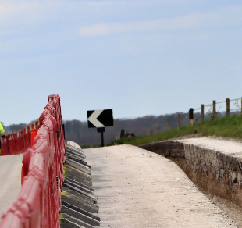 | Conclusion  The SSE Bordon project established a comprehensive and self sufficient delivery model in which Durkin and Sons was fully responsible for operational resource, team management, plant provision, and on-site supervision. By aligning operations with SSEN safety policies, technical standards, and delivery expectations, Durkin and Sons delivered efficient installations of critical 33kV cable infrastructure. Successful fulfilment of these obligations supports SSEN’s broader network enhancement goals, ensuring a resilient, reliable electricity system for the region while maintaining high standards of safety, professionalism, and customer care.

