 |  | Case Study | August 2023  Issue 1
 |  | Crawley Data Centre 132kV
Client  Freedom Energy  Location  Crawley, West Sussex  Contract value  £3.5m  Services  Full Feasibility Detailed Design Construction & delivery of offsite cables installs Temporary works design Traffic Management Excavation of Urban highway As laid drawings Backfill & reinstatement |  | 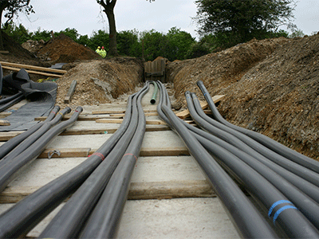

Project Summary
The construction of Digital Realty’s new data centre at Manor Royal, Crawley required the delivery of an N1 secure 132kV dual circuit power connection from the point of connection at Three Bridges Grid. Freedom, acting as Principal Designer and Tier 1 contractor, appointed Durkin & Sons to design and deliver the 4km offsite contestable works, providing 50MVA of capacity via two diverse 132kV cable routes built to UK Power Networks (UKPN) adoptable standards.
The project involved detailed feasibility analysis, extensive stakeholder engagement, complex urban construction, and strict compliance with UKPN engineering specifications. A combination of amenity land and dense urban environments required careful planning including liaison with local authority for opening and closing notices for excavation, duct installation, joint bay construction, and cable pulling operations, all while minimising disruption to residents, businesses, and road networks.
Durkin & Sons successfully delivered the offsite infrastructure—including duct installation, 132kV XLPE cable installation, fibre communications, joint bay construction, and permanent reinstatement—ensuring that both circuits were fully compliant, fully documented, and ready for adoption by UKPN. The project was executed with a strong focus on safety, environmental considerations, risk management, and collaborative planning with local authorities.

Project Overview
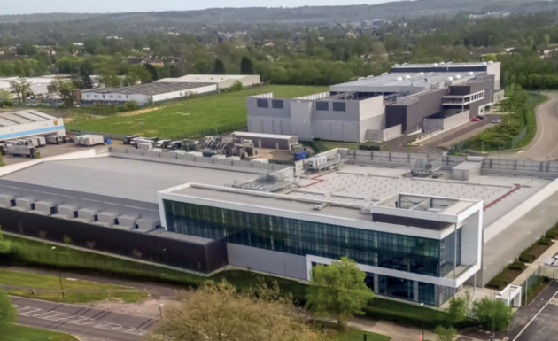  Engineering Challenges & Solutions  The client required diverse 132kV circuits were installed to ensure security of supply. In an already congested urban environment, finding two technically and spatially independent routes was significantly constrained by existing utilities and infrastructure.  - A comprehensive desktop feasibility study identified and eliminated impractical corridors early.  - Two viable routes—minimising overlap and avoiding major congestion—were selected.  - Detailed trench configuration, joint bay design, and cable pulling assessments ensured both routes met UKPN standards for diversity.  Four Special Engineering Difficulties (SEDs) were identified on the initial route corridors, these engineering difficulties restricted available depth, alignment, and the ability to install new 132kV circuits safely.  - Routes were redesigned around SEDs to avoid complex and risky engineering interventions.  - Alignment adjustments focused on passing through residential streets rather than primary highways with heavy utility congestion.  - This reduced technical risk, programme delays, and interface with critical transport structures.  Technical Installation of 132kV XLPE Cables long installation distances, constrained joint bay locations, and the requirement for UKPN approved materials demanded precise planning and execution.  - Installation of a fully designed duct system with pre-planned installation and temporary works.  - Construction of joint bays to UKPN specifications with controlled environmental and safety procedures.  - Installation of 300mm² aluminium 132kV XLPE cable with correct bonding arrangements and approved accessories.  - Fibre optic communication systems installed including fibre pits, concurrently for protection and control.  3.5km of the route passed through highly congested urban roads with high traffic volumes, extensive underground utilities, and sensitive receptors (vulnerable residential properties, commercial units, medical facilities).  - Early engagement with the Local Authority to coordinate permits, traffic management, and working windows.  - Staged construction and phased traffic management to maintain local access and minimise disruption.  - Coordination meetings with project partners to respond to emerging risks, such as concurrent utility works.  Existing high voltage cables, telecoms ducts, gas mains, and water networks posed significant clash risks during trenching and joint bay excavation.  - Detailed analysis of all statutory undertakers’ utility records.  - End to end clash assessments and updates following trial holes.  - Flexible trench alignment and depth adjustments to maintain clearance envelopes and comply with UKPN cable separation requirements. |  |  | Project Deliverables  1. Excavation of urban highways, installation of ducts over complete route,  2. Backfill and permanent reinstatement.  3. 300mm2 Aluminium Conductor, 132kV XLPE Cable  4. Cable installation into ducts  5. Fibre installation to provide control systems communication  6. Construction of 132kV joint bays including of the 132kV cables.  7. Full traffic management  8. Provision of detailed as laid drawings and information
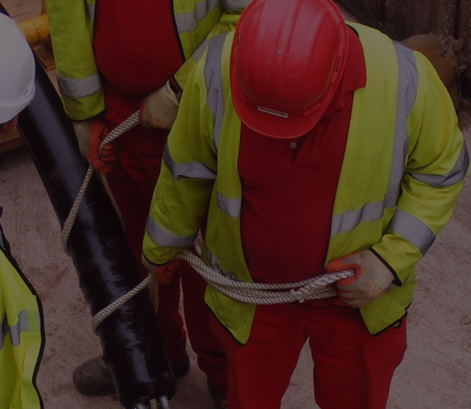 | Conclusion  The successful delivery of Digital Realty’s new data centre demonstrates the effectiveness of early stage planning, rigorous engineering design, and collaborative project management across all stakeholders. By addressing significant Special Engineering Difficulties, managing complex urban construction environments, and adhering to stringent UKPN standards, the project team ensured a resilient, adoptable, and future-proof power connection. The coordinated efforts of Freedom, Durkin & Sons, UKPN, and the local authority enabled the works to be completed safely, efficiently, and with minimal disruption to the surrounding community. The result is a robust high voltage infrastructure asset that provides secure N-1 supply capability and supports the long term operational needs of the data centre and local distribution network.

