 |  | Case Study | September 2025  Issue 1
 |  | Shripney Cable Works
Client  SSEN  Location  Bognor Regis  Contract value  £3.5m  Services  Route preparation Duct installation Design Assessment Thermal performance verification Sheath bonding Compatibility assessments Jointing activities to XLPE & fluid filled cables |  | 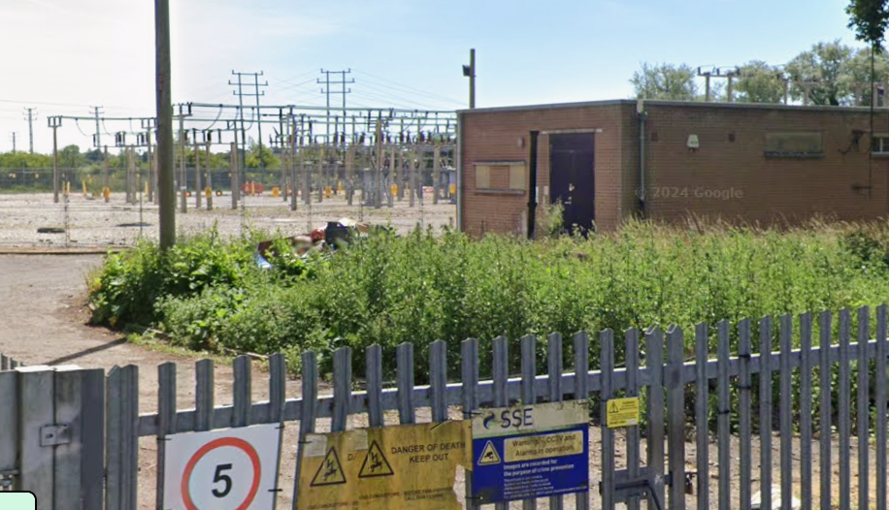

Project Summary

SSE’s Shripney–Argyle Road 33 kV reinforcement project involved replacing approximately 700 m of existing overhead line with an underground XLPE cable solution to improve network resilience, reliability, and environmental integration in the Bognor Regis area. The project introduced 370 m of new Nexans 630 mm² aluminium 33 kV XLPE cables, which were single point bonded and connected between existing 240 mm² Cu fluid filled cables from Argyle Road Substation and existing 400 mm² Al XLPE cables running toward Shripney Substation. Circuits 1 and 2 will continue to operate as a dual circuit route with winter/summer continuous ratings of 30.4 MVA (532 A), with each circuit required to carry full load under outage conditions.

Project Overview
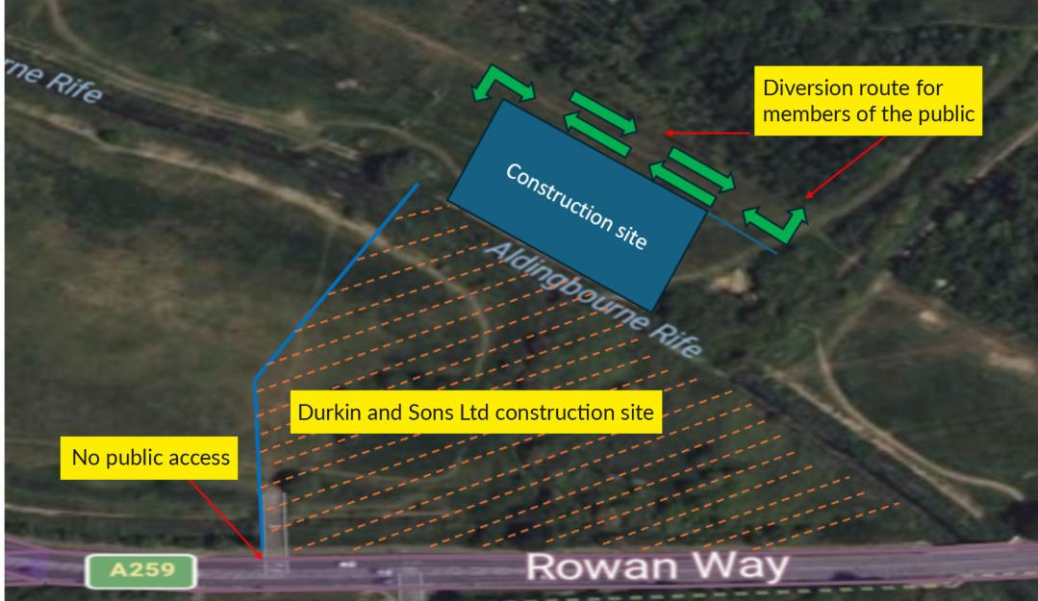  Engineering Challenges & Solutions  Operational delivery followed SSEN’s proposed installation corridor from Ash Grove to The Brooks, incorporating both open cut trenching and 300m HDD sections. The existing 3core fluid filled cables were cut and jointed to the new XLPE cables using Groove transition joints, maintaining circuit integrity and enabling the retirement of the overhead line.  The dual circuits were installed either in shared or individual trenches with a minimum axial spacing of 620 mm, and burial depths of 900 mm in roadways and 1150 mm in agricultural land. HDD installation maintained 5 m circuit spacing to allow thermal dissipation and protect long term rating performance. Thermal assessments were applied to all crossing points and potential heat sources to confirm compliance with the continuous 532 A rating requirement, including full load operation during circuit outages. |  |  | Project Deliverables  Review and assessment of system design, bonding philosophy, and installation configuration.  Verification of thermal performance, circuit spacing, and installation depth across road, agricultural land, and HDD sections.  Recommendations for cable rating compliance, sheath bonding, and mitigation of thermal constraints.  Provision of bonding equipment consistent with single point bonding requirements for the new XLPE section.  Supply of pressure tanks and associated pipework  Installation of 33 kV 3c Fluid Filled to 3×1c XLPE joints at Ash Grove.  XLPE to XLPE size transition joints connecting to the existing 400 mm² XLPE cables at The Brooks.  Compatibility assessment between new cables and existing fluid filled and XLPE systems.  Review of HDD design parameters, including 5 m circuit spacing and installation depth of up to 9 m.
 | Conclusion  This project modernised a key 33 kV route between Shripney and Argyle Road by replacing overhead line sections with a robust underground cable system, enhancing operational reliability and futureproofing the local network. Prysmian’s involvement supported SSEN’s delivery through specialist design input, high performance bonding solutions, and the provision of Groove transition jointing technology needed for integration with legacy and modern cable systems. Successful execution ensured the dual circuit maintains its required thermal rating, supports secure supply to the Bognor Regis area, and aligns with SSEN’s long term network resilience and sustainability objectives.

