 |  | Case Study | October 2019  Issue 1
 |  | Velmore Dual 33kV Circuit Install
Client  SSEN  Location  Eastleigh, Hampshire  Contract value  £3.5m  Services  Principle Contractor Detailed route design Cable pulling design Installation of ducts Testing and cold commissioning 33kv jointing Backfill & reinstatement Traffic Management Temporary Works HDD Design & Deliver |  | 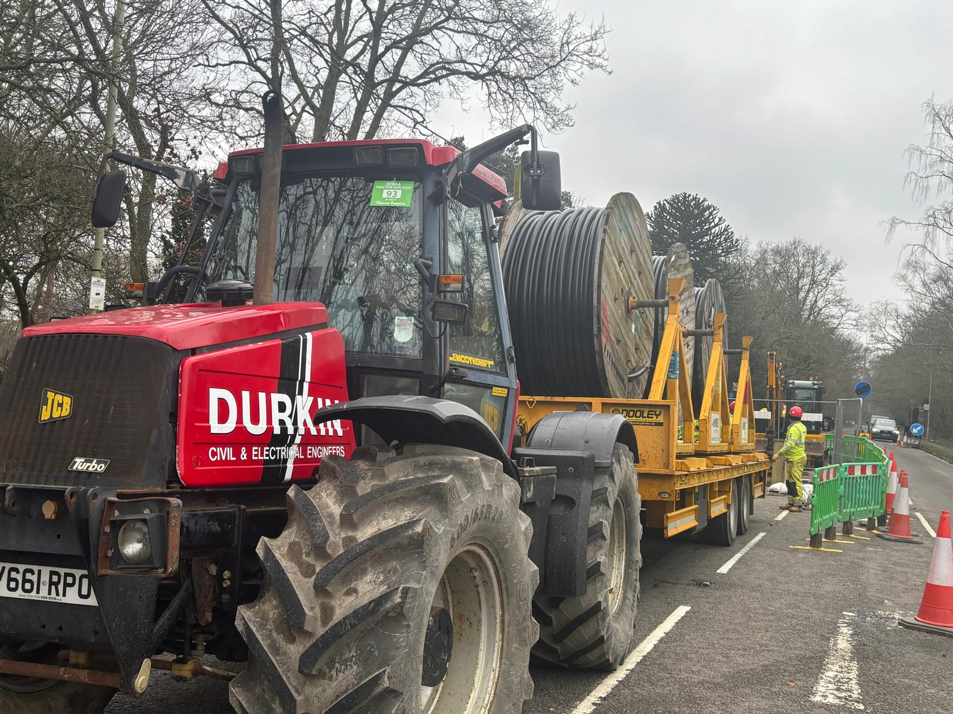

Project Summary

Durkin & Sons were appointed by SSEN as Principal Contractor for the delivery of a new dual 33kV underground circuit between Hedge End and Velmore substations in Hampshire. The scheme comprised 13km of route across both agricultural land and densely urbanised highways, requiring detailed design development, extensive stakeholder engagement, complex traffic management arrangements, and specialist engineering solutions to deliver the project safely and efficiently.
The client provided cable, ducts, and tiles whilst Durkin & Sons undertook full Principal Contractor responsibilities, including detailed route design, surveys, cable installation, jointing, testing, and full reinstatement.

Project Overview
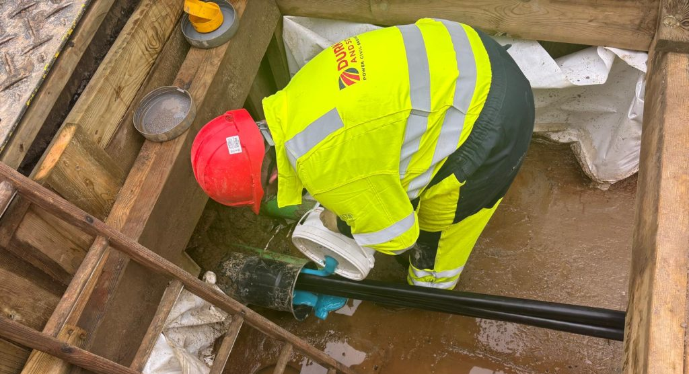  Engineering Challenges & Solutions  The route’s length and complexity resulted in a number of Special Engineering Difficulties (SEDs). These were successfully mitigated through collaborative design refinement with SSEN and proactive stakeholder engagement. Key challenges included:  1.Watercourse crossing at Monks Brook: A revised HDD solution was designed and implemented to overcome ground and environmental constraints.  2.Railway and highway constraints: HDD installations were used for two rail crossings; containment solutions were agreed with Highways England for crossings under the M3 and M27.  3.Urban traffic impacts: Sequenced traffic management and contingency plans were developed to maintain emergency diversion routes and protect motorway resilience.  4.Cable pulling risks: Works were supported by project-specific cable pulling calculations and SMSTS supervision to ensure safe operations |  |  | Project Deliverables  1.Final design and route proving.  2.Traffic Management Plan for sequential working.  3.Three Directional Drill site set ups two under rail crossings.  4.Excavation and Ducting of two 33kV circuits Velmore to Hedge End substations.  5.Cable installs of two circuits comprising three single cores in trefoil.  6.All jointing and sheath testing required to prove each circuit integrity from end to end.  7.All permanent reinstatement.  8.Provision of as built and laid information.
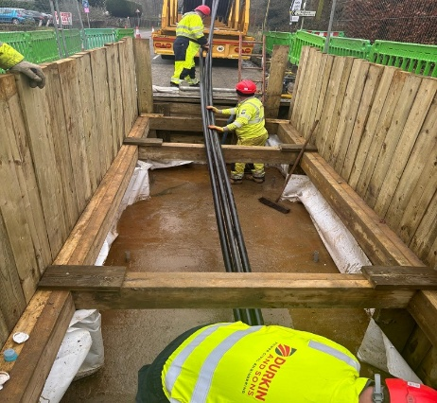 | Conclusion  All works were delivered in accordance with SSEN’s safety and quality standards. A comprehensive project risk register was maintained. Mitigation actions—such as detailed design reviews, traffic controls, testing regimes, and contingency planning—ensured safe delivery.  The project successfully delivered two fully commissioned 33kV circuits with full reinstatement, as-laid documentation and testing certificates. Through robust design control, proactive stakeholder coordination, and strong project management, Durkin & Sons completed a technically challenging scheme while maintaining safety, environmental compliance, and community confidence.

